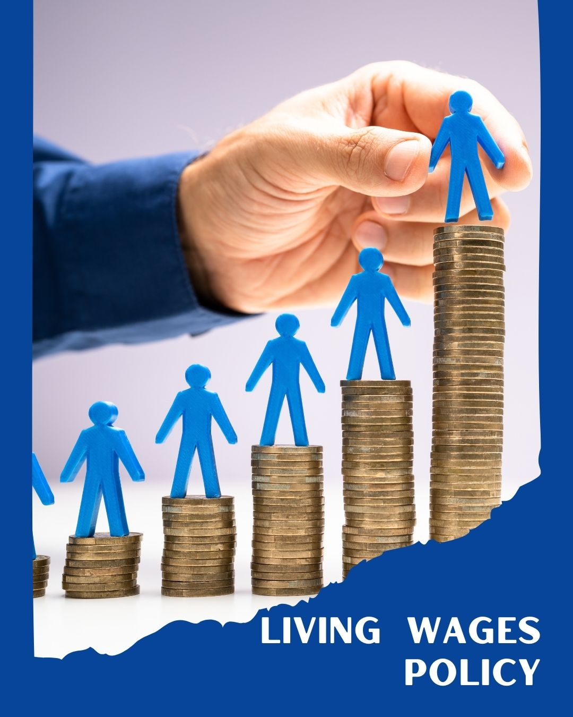
ARSH FASHIONS PVT. LTD.

A UNIT OF PERMESHWAR FASHIONS IMPEX PVT. LTD.

TABLE OF CONTENTS
PREFACE 1
SCOPE 2
POLICY DECLARATION 2
INITIATIVES AND TARGETS IN ALIGNMENT WITH SDGs 2
PERFORMANCE REPORTING 3
REVIEW MECHANISM 4

PREFACE

Arsh Fashion Pvt. Ltd. is committed to ensuring that all employees are compensated fairly, in a manner that allows them to meet the basic needs of themselves and their families. As a responsible garment manufacturing company, we acknowledge the importance of a living wage in promoting the well-being and dignity of our workforce. This policy outlines our approach to implementing and maintaining living wage standards across all levels of employment.

SCOPE

This Policy is applicable to following sites and all of its employees, workers, sub-contractors and other stakeholders:

Sr. No. | Site | Address
1 | ARSH FASHOINS Pvt. Ltd. | Plot No.194, IInd Phase, G.I.D.C., Vapi - 396195,  Gujarat, India.

POLICY DECLARATION

Arsh Fashion Pvt. Ltd. is dedicated to providing a wage that not only meets legal requirements but also ensures that employees can afford essentials such as food, housing, healthcare, education, and transportation. We are committed to assess wages regularly and make necessary adjustments in line with inflation, cost of living, and industry benchmarks. This policy applies to all employees, regardless of their position, and includes a commitment to working closely with suppliers to ensure fair wage practices throughout our supply chain. Our baseline year for measuring progress in living wage practices is 2022.

INITIATIVES AND TARGETS IN ALIGNMENT WITH SDGs





- Ensure that 100% of employees earn a wage that is at least 10% higher than the local minimum wage, with annual reviews to adjust for inflation and cost of living changes by year 2030.
- Collaborate with suppliers to adopt living wage practices and ensure compliance throughout the supply chain.
- Ensure open communication with employees regarding wage policies and provide channels for feedback and grievances related to wage concerns.
- Conduct annual surveys to monitor employee satisfaction with wage levels, aiming for at least an 85% satisfaction rate by year 2030.
- Introduce financial literacy programs to help employees better manage their wages and plan for the future.
- Ensure that wage structures are gender equitable and non-discriminatory, providing equal pay for equal work.
- Achieve and maintain a 0% gender wage gap by conducting annual pay equity audits and addressing any discrepancies by year 2030.

PERFORMANCE REPORTING

Performance towards living wage targets will be tracked and reported annually. The report will include data on wage levels, employee satisfaction, and supplier compliance. Any gaps in achieving targets will be identified, and corrective measures will be implemented. This report will be shared with relevant stakeholders to ensure transparency and accountability.

REVIEW MECHANISM

This Living wage policy will be reviewed annually by HR in response to economic changes, inflation, and employee feedback. Adjustments to wage levels will be made as needed to ensure ongoing compliance with the living wage commitment. The review will involve consultation with employee representatives, industry experts, and external auditors to ensure best practices are followed.

REV. No. 01

EFFECTIVE FROM: 01.01.2024 NEXT REVIEW DATE: 01.01.2025

Approved By

Management Representative

